**Abhay Gupta**

**D15b**

**18**

**AIM:**

To develop a website and host it on your local machine using a VM, with a reference to hosting a static website on Amazon S3 (AWS).

**THEORY:**

**Introduction:**

In DevOps, this experiment involves developing a website using a tech stack that includes **HTML, CSS, JavaScript**, and frameworks like **React** or **Angular**, with backend technologies such as **Node.js** or **Python**. The website is first hosted on a local development environment and then transitioned to **Amazon S3** for scalable, cloud-based hosting. This approach highlights the advantages of both local and cloud environments.

**Hosting on a Local Machine Using XAMPP**

**Setting Up a Local Development Environment with XAMPP:**

**XAMPP** is an open-source, cross-platform web server solution stack package developed by **Apache Friends**. It includes:

* **Apache**: A widely-used web server software.
* **MySQL/MariaDB**: Database management systems.
* **PHP**: A server-side scripting language.
* **Perl**: A high-level programming language.

**Pros:**

* Complete control over the development environment.
* Useful for development and testing phases.

**Cons:**

* Limited scalability.
* Requires manual management of infrastructure and updates.

**Hosting a Static Website on Amazon S3 (AWS)**

A static website consists of fixed content with HTML files and does not require server-side processing. This type of website is typically faster and easier to host.

**Introduction to AWS S3:**

**Amazon S3 (Simple Storage Service)** is a scalable object storage service that provides a simple web services interface to store and retrieve any amount of data at any time from anywhere on the web.

**Pros:**

* Highly scalable and cost-effective.
* Minimal management required.
* High availability and durability of data.

**Cons:**

* Limited to static content.
* Less control over the hosting environment compared to a VM.

**Steps:**

Hosting on a Local Machine Using Xampp

* 1. Download, Install and Launch Xampp. Start the actions of Apache and MySQL

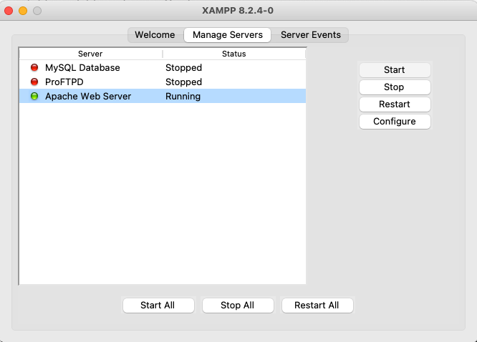

* 1. Create an index.html and its corresponding css file. Save both files in an appropriate folder as xampp => htdocs => random.html.

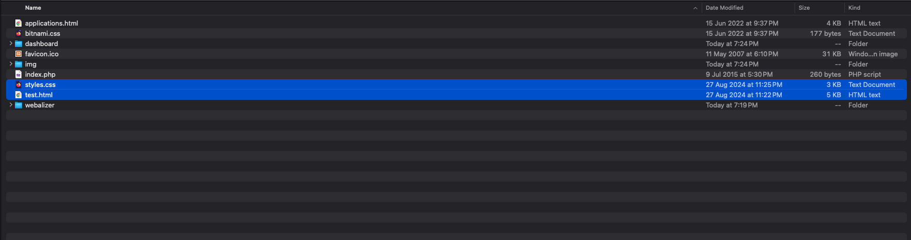

* 1. Go to any browser and search for <http://localhost/random.html>

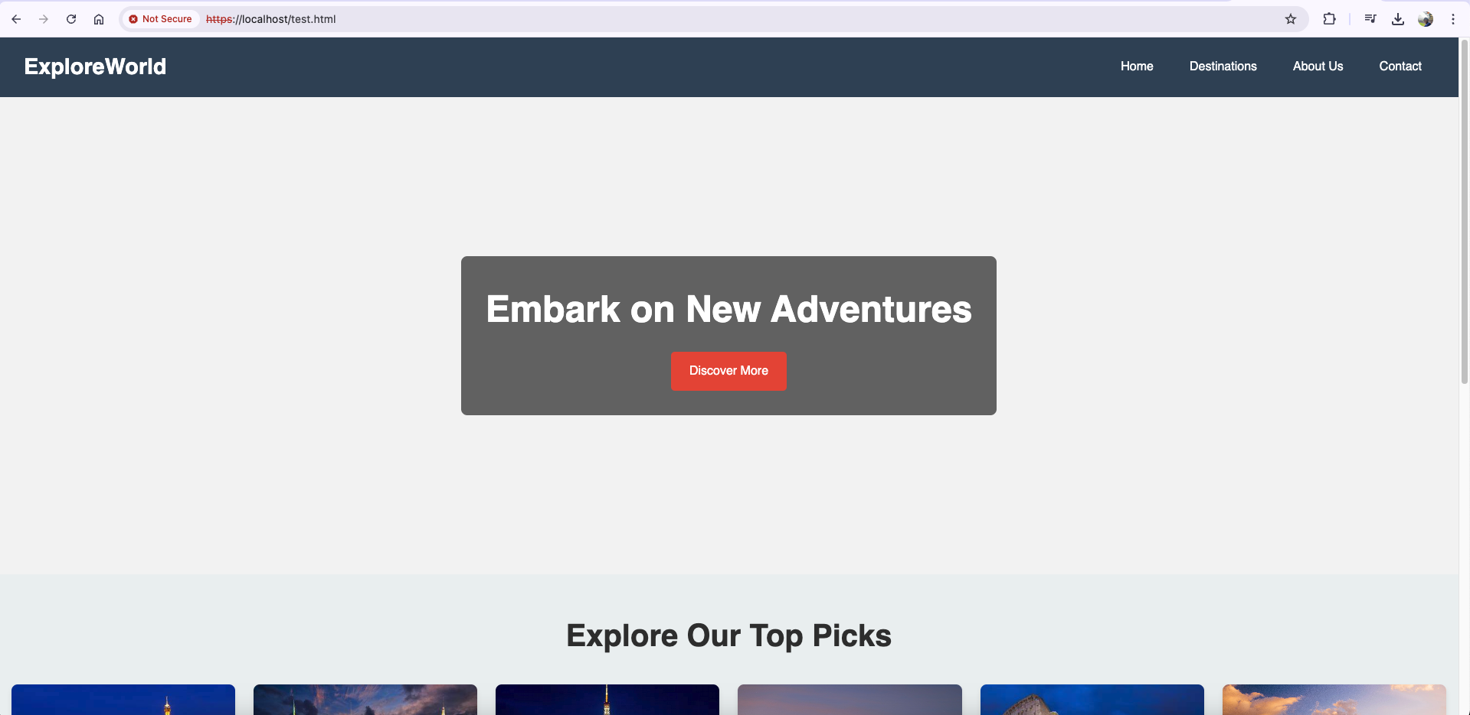

Hosting a Static Website on Amazon S3 (AWS)

Go to AWS academy website. Solve the Module Knowledge Check. Launch AWS Academy

Learner Lab and click on AWS beside the green logo. (logo will become green once the start lab

is clicked.)

Search for S3 and create a bucket.



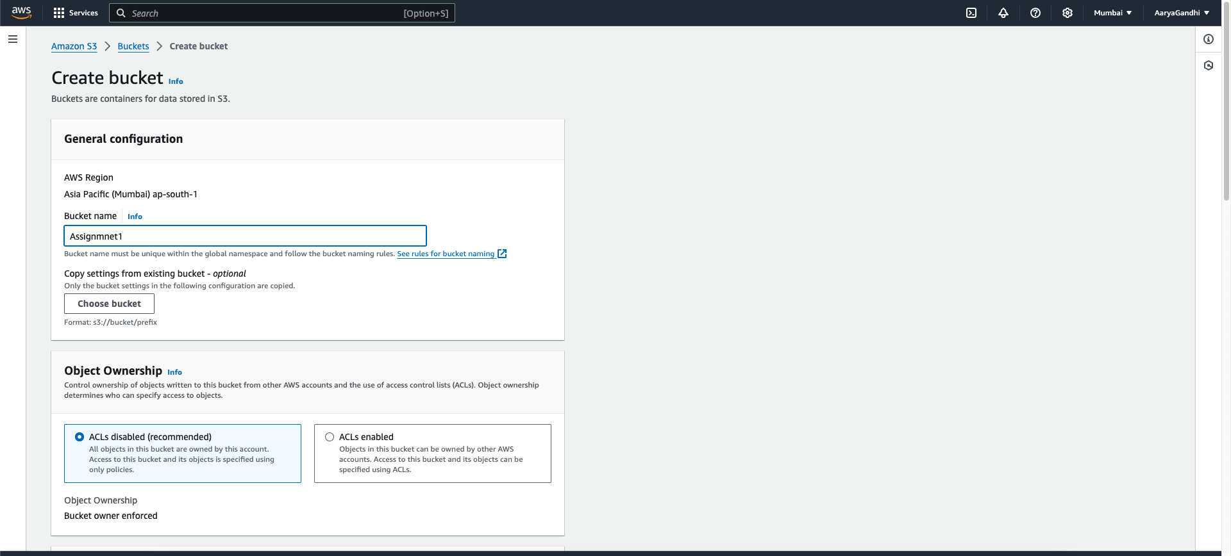

* 1. Click on the created bucket and upload the index.html and its corresponding css



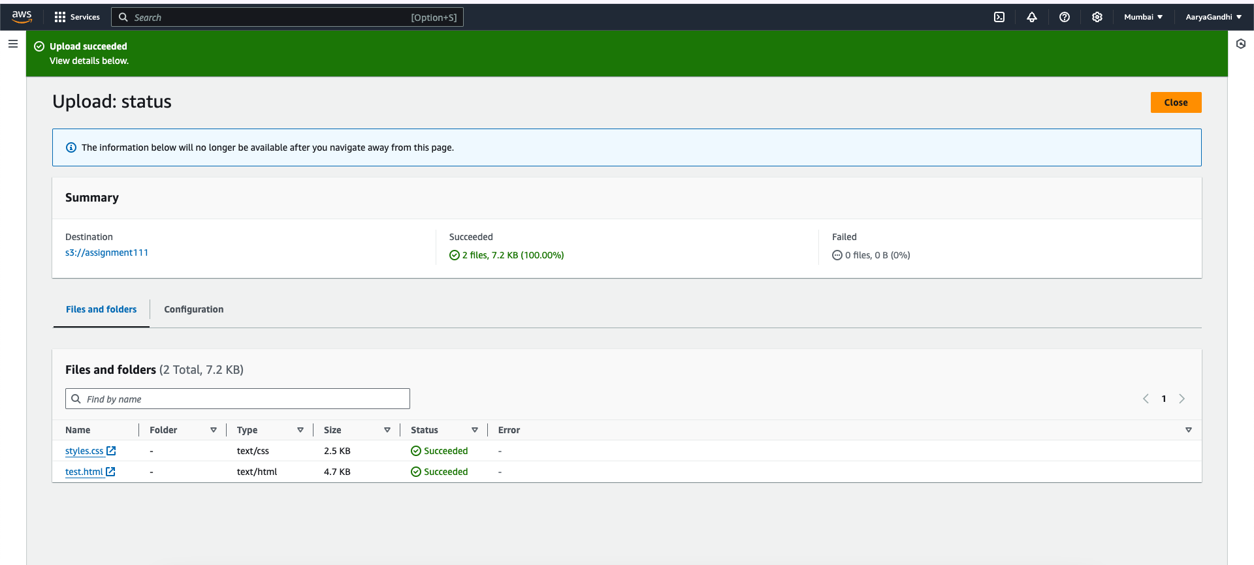

* 1. Go to the Properties section and enable the static website hosting.



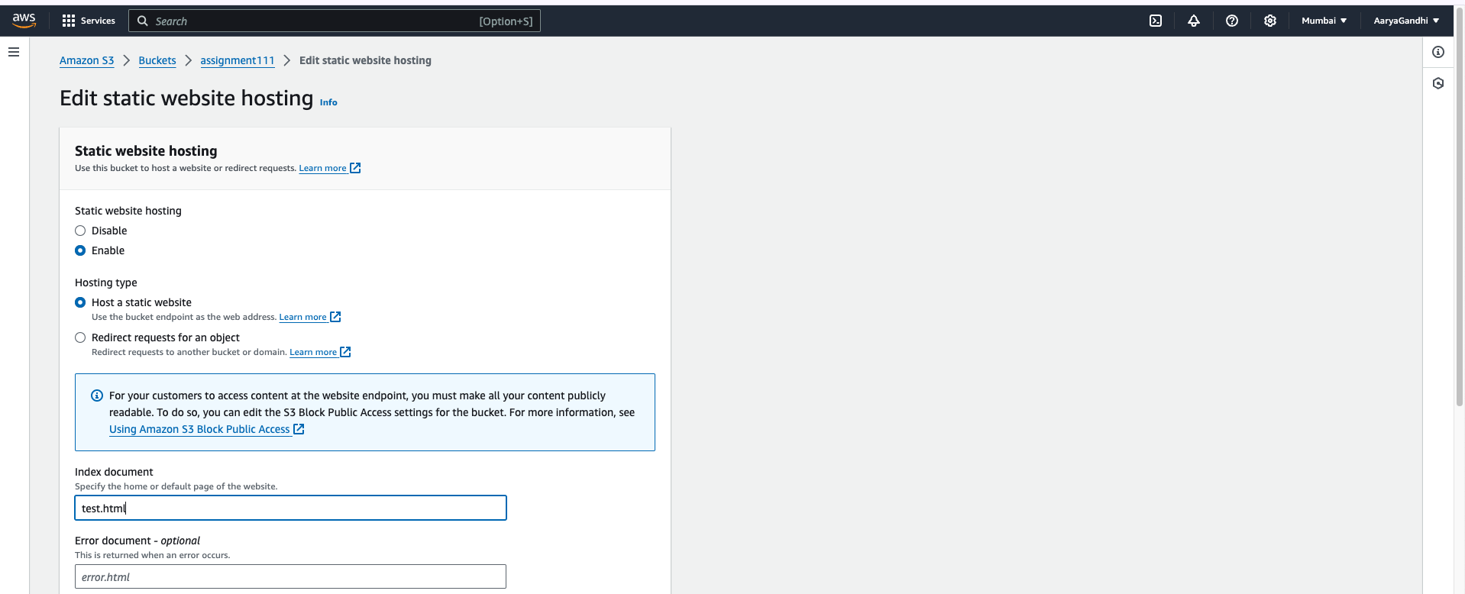

* 1. Unselect the (main) option of Block public access. (By default, it is selected while creating the bucket). It gives public access to use our website.
  2. Go the permission section of the bucket and go to “object ownership” and enable ACL’s Enable
  3. After saving th changes go to Ojects section and then select all items->actions->Make Public Using ACL



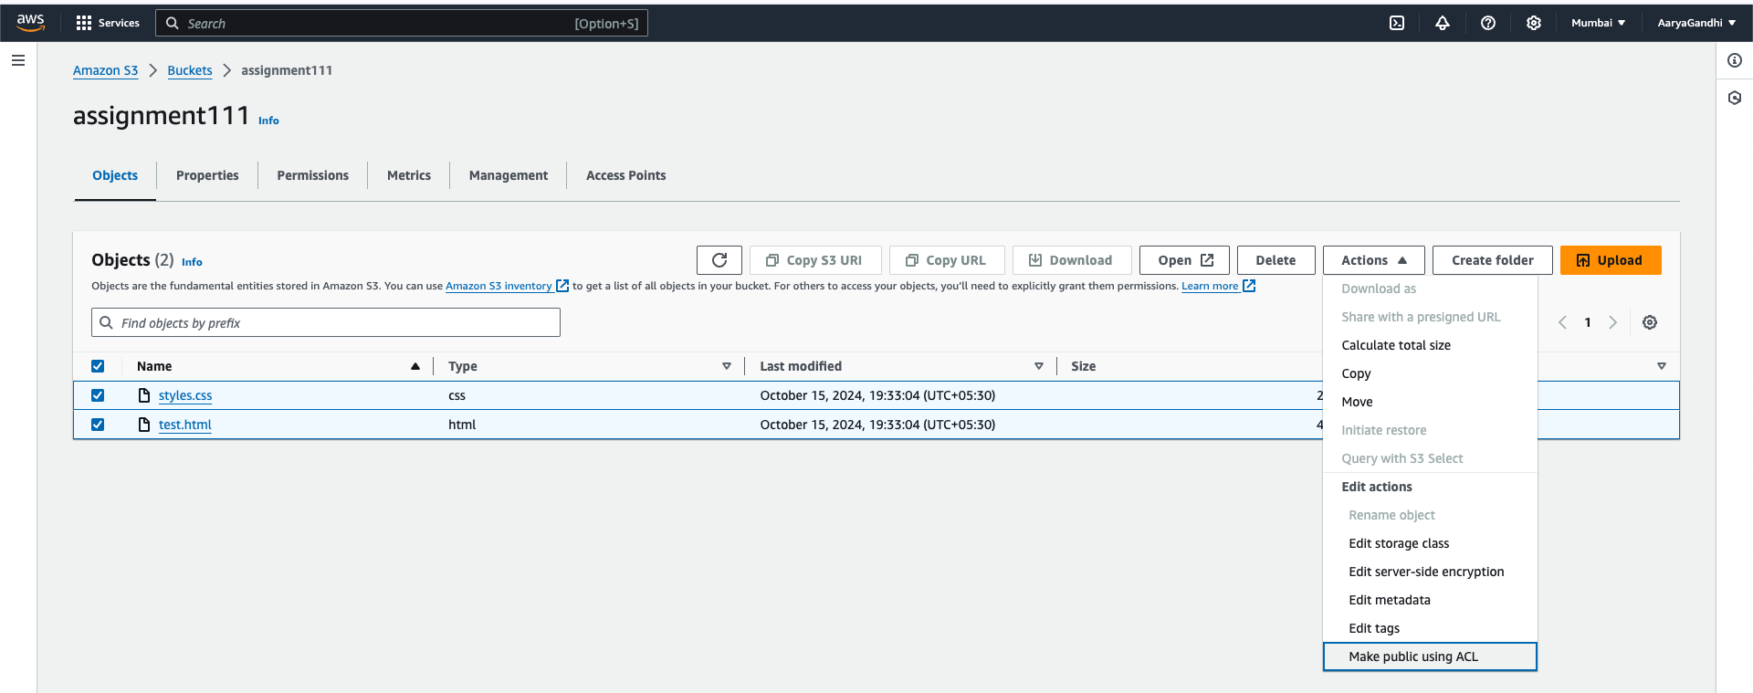

* 1. Go to the Objects section and select the index.html file. Then the Copy URL option will get activated. Click on it and paste it on the new tab.

